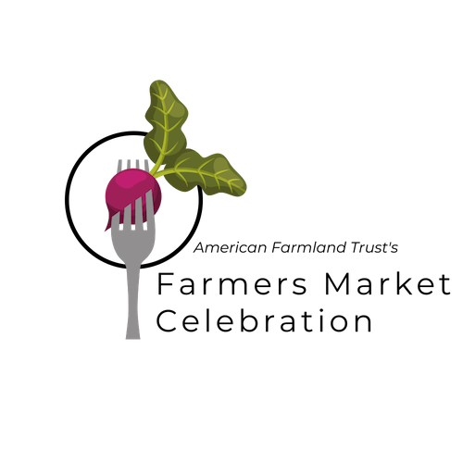
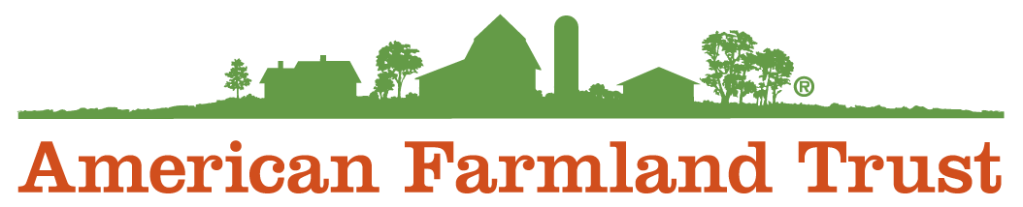

2020 Farmers Market Celebration
Communications Toolkit

Find more information and endorse your favorite market at markets.farmland.org

Introduction:

For over a decade, American Farmland Trust’s Farmers Market Celebration has highlighted the important role farmers markets play in communities across the nation. Long pillars of local food in urban centers and town squares, in the age of coronavirus, farmers markets have gained the recognition they deserve as essential businesses ensuring farmers have a venue to sell their goods and families have a place to access fresh, healthy food. In 2020 it has become clear: America’s farmers markets are more important than ever.

This year, our 12th annual Farmers Market Celebration is making it easier than ever for shoppers to support their favorite market and help them earn national recognition including a brand new cash prize for the top markets. Visit markets.farmland.org between June 22 and Sept. 20, 2020, to endorse your favorite market.

Most importantly, get out and support your local farmers market this summer if you’re able to. But please do so with patience and respect for vendors and fellow customers. Markets around the country are working hard every day to make sure that markets can continue operating safely. This may mean markets look a little different this summer and that you’ll need to follow new rules and protocols. Just remember, everyone is doing their best.

Whether you’re a market manager or a dedicated farmers market shopper, you’ll find information below that will help you make the most of the 2020 Farmers Market Celebration.

Connect with us
- Find your market, vote, and access resources: http://markets.farmland.org
- Email us: marketinfo@farmland.org
- Like American Farmland Trust on Facebook
- Follow @Farmland on Twitter
- Follow @americanfarmlandtrust on Instagram
- Sign-up for email updates: www.farmland.org/sign-up

In this toolkit
We developed this toolkit to help farmers market operators, vendors, and customers recognize the essential markets making a difference in their communities through participation in American Farmland Trust’s 12th annual Farmers Market Celebration. This summer, for the 12th consecutive year, supporters will find and endorse their favorite market for a chance to earn national recognition, a cash prize, and more!

We hope you find the following resources helpful. For more information, please contact AFT’s digital communications manager, Greg Plotkin, at gplotkin@farmland.org.

- Farmers Market Celebration Overview and Messaging Points
- Sample Press Release
- Sample Email
- Sample Blog/Language for E-Newsletters and Websites
- Sample Social Media Posts
- Infographics and Visual Assets

Farmers Market Celebration Overview and Messaging Points
Overview
Running from June 22 to Sept. 20, 2020, AFT's 12th annual Farmers Market Celebration showcases the essential markets across the nation making a difference for farmers, ranchers, and communities. During this time, market shoppers and supporters can endorse their favorite market by visiting markets.farmland.org. In addition to recognizing the top markets in each region of America, the Celebration will crown an overall "People's Choice" winner as the top-endorsed market in the country.
This isn't a normal summer for farmers market operators. The coronavirus pandemic has forced market operators to adopt new policies and procedures to keep vendors and customers safe, all while ensuring communities have continued access to local, healthy food.
To recognize the vital role farmers markets are playing this year, AFT is pleased to be able to offer cash prizes for the markets that finish in the top three of the "People's Choice" category — $1,000 for first, $500 for second, and $250 for third. These funds will be awarded to markets to go towards marketing, communications, and other needs that help expand the market’s reach and impact.
Message Points
AFT’s Farmers Market Celebration
- For the last 12 summers, AFT’s Farmers Market Celebration has elevated the essential role farmers markets play in helping communities access local food and helping farmers connect directly with customers.
- American Farmland Trust’s Farmers Market Celebration helps connect markets and customers year-round while helping to elevate the essential role markets play in communities.
- Farmers markets have been at the leading edge of educating consumers about where food comes from, and reinforcing AFT’s message of No Farms No Food.
- Endorsing your favorite farmers market this summer can help them earn national recognition and cash prizes.
- Participating in AFT’s Farmers Market Celebration is easier than ever with AFT’s redesigned website that streamlines voting, plots markets on a Google map, and provides additional resources for market managers.

Farmers Markets as Essential Businesses

- Access to fresh, healthy, local food has become more important than ever. Farmers markets have and will continue to provide this essential service to communities across the nation.
- During the coronavirus pandemic, farmers markets have become cemented as essential businesses, helping to connect farmers to customers, and customers to local, healthy food.
- In a time of social distancing, many people feel safer shopping at open-air markets than in their local grocery store.
- Many farmers markets have adapted new safety measures and protocols to keep their markets open and their customers, staff, and vendors safe.
- As eaters, the most important tool we have at our disposal to keep farmers and ranchers in business is our fork.
- Farmers and food businesses rely on farmers markets to connect directly with consumers. Cutting out the middleman means producers can keep more of our food dollars.

Press Release Template

[Your Farmers Market Name] Encourages Supporters to Participate in
Summer-long Farmers Market Celebration
FOR IMMEDIATE RELEASE
Date
Media Contact (Your name, email, and phone number)
YOUR TOWN, STATE, DATE –
Today, [Market Name] is encouraging supporters to participate in American Farmland Trust’s 12th annual Farmers Market Celebration, which runs from June 20 to September 22, 2020. Shoppers are encouraged to come to the market [market hours, location] and then visit markets.farmland.org, where they can endorse the market, putting it in the running for national recognition and cash prizes.
American Farmland Trust, a national nonprofit dedicated to saving farmland, promoting sound farming practices, and keeping farmers on the land, has run the Celebration for 12 consecutive years, elevating the essential role farmers markets play in helping communities access local food and helping farmers connect directly with customers.

“In many regions, especially during these unprecedented times, farmers markets have been vital to keeping existing farms in business and enabling new farms to get started,” said John Piotti, American Farmland Trust president and CEO. “During the coronavirus pandemic, farmers markets have served as essential businesses, helping to connect farmers to customers, and customers to local, healthy food.”

In 2020 it has become clear: America’s farmers markets are more important than ever. [Insert specific measures your market has taken this year for customers safety]

To recognize the vital role farmers markets are playing this year, AFT will, in addition to recognizing top markets by region, offer cash prizes for the markets that finish in the top three of the "People's Choice" category— $1,000 for first, $500 for second and $250 for third. These funds will be awarded to markets for marketing, communications, and other needs that help expand the market’s reach and impact.
[Insert quote from a spokesperson for your farmers market about why you think your market deserves to be recognized]

To learn more and participate, visit markets.farmland.org today. YOUR MARKET NAME. (Brief sentence about a particular program you’re proud of at the farmers market. The Celebration will run during the summer season and end Sept. 22, 2020.
###

NOTE: When sending to media outlets, include a photo from your local farmers market, as well as your market’s logo and the logo for the Farmers Market Celebration (found in the “Graphics” section of the website)

Email Template

Subject line: Show some love for Your Market

Dear First name,

Do you think YOUR MARKET is one of the best in the country? OF COURSE!

We need your recommendation to let others know how the [farmers market name] is helping farmers and bringing together the [your town, city or neighborhood] community.

Head over to American Farmland Trust’s 12th annual Farmers Market Celebration webpage and endorse us. Your vote could help us earn national recognition and even cash prizes!

American Farmland Trust is recognizing markets throughout the country and will be awarding cash rewards for the markets that finish in the top three of the "People's Choice" category at the end of the summer.

In its 12th consecutive year showcasing the essential markets across the nation making a difference for farmers, ranchers, and communities, AFT’s Farmers Market Celebration is running from June 22 to Sept. 20, 2020 this year. So, head to markets.farmland.org before Sept. 20 to show your support for [Your Market Name].

This year, [Your Market Name] is [what you’re doing to excel and keep customers safe].

Visit the market [market hours, location] and help put [hometown name] on the map! [HYPERLINK TO YOUR MARKET PAGE DIRECTLY]. Thanks for your help, and we’ll see you at the market!

Blog Post Template
Share this post on your blog or ask an influential blogger in your community or region to post on your behalf.

Title: Now more than ever, what you put on your fork matters.
Access to fresh, healthy, local food has become more important than ever. Farmers markets, including [Your Farmers Market], have and will continue to provide this essential service to communities across the nation.
During the coronavirus pandemic, farmers markets have served as essential businesses, helping to connect farmers to customers, and customers to local, healthy food. In a time of social distancing, we’ve adapted new safety measures and protocols to keep our market open and our customers, staff, and vendors safe.
To recognize the vital role of farmers markets, the national nonprofit American Farmland Trust is holding its Farmers Market Celebration again this year. This year marks AFT’s 12th consecutive year showcasing the essential markets across the nation making a difference for farmers, ranchers, and communities. Endorsing [Your Farmers Market] this summer can help earn it national recognition and cash prizes.
The most powerful tool we have to support our local farmers and food economies is our fork. Farmers and food businesses rely on farmers markets to connect directly with you as consumers. Now is your opportunity to show your support for of these essential markets.

If you have ever been to [Your Farmers Market], you may already know that it’s a gold standard for farmers markets in the area. If you haven’t been to the market before, here are a few reasons why [Your Market Name] deserves nationwide recognition:

To help shine a light on [Your Farmers Market], go to www.markets.farmland.org and search for [Your Farmers Market (or hyperlink directly to your market’s unique page).

Include a photo from your local farmers market, as well as your market’s logo and the logo for the Farmers Market Celebration (found in the “Graphics” section of the website)

Social Media
Follow the Celebration on social media, share our posts (or make your own!), and engage your market’s community. In your outreach, be sure to share what your market does that makes you stand out.
Be sure to encourage your shoppers to use social media by posting pictures, videos, and testimonials of your farmers market using the hashtag #NoFarmsNoFood. Remind them to tag your market handles and AFT’s.

Help us grow the national conversation about the best of America’s local farmers markets by using the hashtag #NoFarmsNoFood.
Facebook Suggested Posts
Support our local farmers at [Your Market Name] this week. Then recommend us as one of the nation’s best farmers markets in @AmericanFarmland’s 12th annual Farmers Market Celebration. Your endorsement could help us earn national recognition and cash prizes! #NoFarmsNoFood www.markets.farmland.org

During the coronavirus pandemic, farmers markets have become cemented as essential businesses, helping to connect farmers to customers & customers to local, healthy food. Show your appreciation and help us continue this work by recommending us as one of the nation’s best farmers markets in @AmericanFarmland’s 12th annual Farmers Market Celebration. Your endorsement could help us earn national recognition and cash prizes. #NoFarmsNoFood www.markets.farmland.org
Instagram Suggested Posts
This summer, recommend us as one of the nation’s best farmers markets in @AmericanFarmlandTrust’s 12th annual Farmers Market Celebration. Your endorsement could help us earn national recognition and cash prizes! Visit markets.farmland.org to participate. #NoFarmsNoFood

In the age of coronavirus, farmers markets have gained the recognition they deserve as essential businesses ensuring farmers have a venue to sell their goods and families have a safe place to access fresh, healthy food. Show your appreciation by recommending us as one of the nation’s best farmers markets in @AmericanFarmlandTrust’s 12th annual Farmers Market Celebration. Your endorsement could help us earn national recognition and cash prizes. Visit markets.farmland.org to participate. #NoFarmsNoFood
Twitter Suggested Posts
Do you think @[your handle] is one of the best farmers markets in the nation? Tell @Farmland by voting for us in their Farmers Market Celebration going on now. #NoFarmsNoFood markets.farmland.org
Farmers markets are essential businesses ensuring farmers have a venue to sell their goods & families have a safe place to access fresh, healthy food. Show your support of our market by voting in @Farmland's Farmers Market Celebration. #NoFarmsNoFood markets.farmland.org

Infographics
Click here to download graphics you can use to encourage your friends, family, and market shoppers to vote for you in the 2020 Farmers Market Celebration.

